

**United States Department of the Interior**

**National Park Service**

**NORTHEAST REGION**

**15 State Street**

**Boston, Massachusetts 02109-3572**

**IN REPLY REFER TO:**

February 28, 2013 Filed Electronically

Kimberly Bose, Secretary

Federal Energy Regulatory Commission

888 First Street, NE

Washington, DC 20426

Comments and Study Requests in Response to the Notice of Intent to File License Application, Filing of Pre-Application Document (PAD), Commencement of Pre-Filing Process and Scoping and Request for Comments on the PAD and Scoping Document: Vernon Hydroelectric Project (FERC 1904-073), Bellows Falls Hydroelectric Project (FERC 1855-045) and Wilder Hydroelectric Project (FERC 1892-026). TransCanada Hydro Northeast, Inc.

Dear Secretary Bose:

**General Comments**

The National Park Service files these comments in order to facilitate the relicensing process for both applicants and offers this agency’s technical expertise on public recreational access, land conservation and preservation and our understanding of the values placed by the general public on river related resources. Together, the five projects currently up for relicensing directly influence almost 170 miles of New England’s longest river and represent five of the nine Connecticut River mainstem dams. The other four dams – the Holyoke Dam (FERC 2004) and the three dams associated with the 15 Mile Falls Hydroelectric Project (FERC 2077) were relicensed relatively recently and Federal Energy Regulatory Commission (FERC) included in each licensing order for those projects a host of comprehensive environmental measures to benefit the public and the shared natural resources associated with the Connecticut River. The FERC has clearly and appropriately recognized the importance of taking a comprehensive look at the current group of Connecticut River relicensings as evidenced by its decision to hold joint site visits, joint Scoping meetings and a Cumulative Effects Meeting as part of the Scoping process; only the third time FERC has done so in a relicensing proceeding.

The U.S. Department of the Interior (DOI) has also recently recognized the importance of the Connecticut River by designating it as the nation’s first National Blueway on May 24, 2012. Secretary Salazar noted that “The Connecticut River Watershed is a model for how communities can integrate their land and water stewardship efforts with an emphasis on ‘source-to-sea’ watershed conservation [as we] seek to fulfill President Obama’s vision for healthy and accessible rivers that are the lifeblood of our communities and power our economies.” Among the stated goals are to advance a whole river and [utilize] a water-based approach to conservation, outdoor recreation, education and sustainable economic opportunities in the watersheds in which we live, work and play.”

The National Blueways System is part of the America’s Great Outdoors Initiative which seeks to establish community-driven conservation and recreation for the 21st century. Both the DOI and the Department of Agriculture identified the Connecticut River as an important priority under America’s Great Outdoors.

The Connecticut River and its 7.2 million-acre watershed includes National Forests, National Historic Sites, National Wildlife Refuges, National Scenic Byways, Partnership Wild and Scenic Rivers, National Recreation Trails, National Natural Landmarks, Important Bird Areas, and segments of the New England National Scenic Trail; the Appalachian National Scenic Trail; the East Coast Greenway Trail; the Northern Forest Canoe Trail; Revolutionary Route National Historic Trail, a Ramsar wetland site, and an American Heritage River, and approximately two million acres of public and private conservation land.

The relicensing of the five projects in the subject proceedings offer a once in a generational opportunity to move forward in achieving the goals of the National Blueways System and the Administration’s America’s Great Outdoors initiative. Together, the projects currently undergoing relicensing impound over 90 miles of formerly free-flowing river and affect river resources from roughly 45 miles above the Wilder Dam downriver almost all the way to the upper reaches of the Holyoke Dam impoundment. The river offers myriad paddling opportunities for canoeing, kayaking and rowing, including multiple-day trips. It flows through many population centers, both urban and rural and is easily accessible to millions of people. However, serious obstacles to multi-day paddling trips: Several of the dams offer either no portage, as at Turners Falls and long and dangerous portages around other dams such as at Bellows Falls. Public access points and campsites (both river and shore access) are limited and inadequate to accommodate a reasonable amount of public recreational use.

**Land Protection**

Although the PAD identifies licensee owned lands within the project boundary, it does not so identify licensee owned lands adjacent to the project boundary. In some cases, these adjacent lands could be appropriate for providing additional recreational access to the river, new trails or connections to existing trails. Permanent protection of these lands would also confer aesthetic benefits to those using the river by providing views from the river of undeveloped lands. Regarding lands within the project boundary, those not integral to project operations should be permanently preserved and in many cases consist of prime agricultural lands. Even those lands currently under Agricultural Preservation Restrictions are only temporarily protected. Permanent protection ensures the long term viability of these important resources. Numerous non-governmental organizations (such as the Vermont Land Trust, the Upper Valley Land Trust, New Hampshire Audubon, the Society for the Protection of New Hampshire Forests and the Connecticut River Watershed Council) as well as the respective State Comprehensive Outdoor Recreation Plans (SCORP) of both New Hampshire and Vermont have identified valuable and important land protection locations and opportunities along the Connecticut River. This information should be identified and used collectively to determine appropriate opportunities for land protection in the context of these relicensing proceedings.

**Comments and Issues Specific to Individual Projects**

Identification of issues is set out below followed by specific study requests and justifications.

**Obstacles to Multi-Day Paddling**

The licensee’s PAD cited the current New Hampshire SCORP (2013-2018) and the Vermont SCORP (2005-2009), both of which identified the need for “water-based” recreational activities. The New Hampshire SCORP specifically focused on the need for a “well-connected and maintained system of trails,” including water-based ones. Multiple-day paddling trips clearly meet such needs, but are limited by the operations of the hydropower dams. Although campsites and boat ramps do exist, the dams and existing portages discourage paddlers seeking to navigate the length of the Connecticut River. Just as fish are challenged by multiple obstacles to their passage, paddlers are similarly discouraged and either abandon their efforts to migrate downriver or more likely do not even consider such a through trip. The licensee’s PAD does not propose and measures to mitigate limits to or enhance the opportunities for multiple-day paddling trips.

*Vernon*

The portage trail at Vernon poses a number of challenges for paddlers. According to a paddler’s comment at the Scoping meeting “Getting out of the river just before the dam is a mess. I've done this 5 times and it's always a mess—junk in the cove, trash, etc.” In addition, the pathway to exit the river is steep and the landing is often muddy. A recent study by the Connecticut River Paddler’s Trail (CRPT) documented the poor condition of the Stebbins Island campsite maintained by TransCanada just below the Vernon Dam. The CRPT notes that the ideal frequency of canoe campsites on flatwater rivers is one for every five river miles, accompanied by canoe and kayak access in every town. The Vernon facility does not provide enough campsites to meet that standard.

*Bellows Falls*

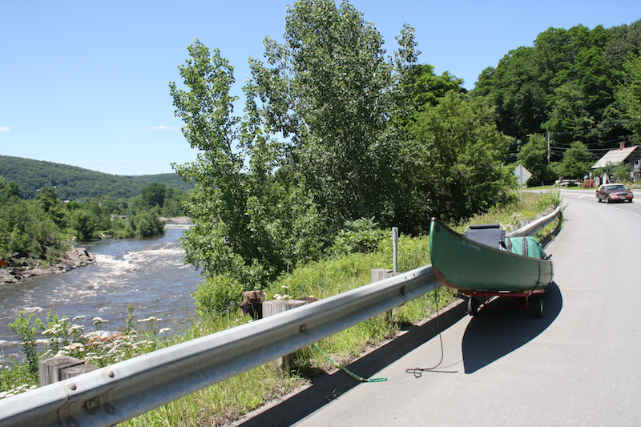The existing portage trail at Bellows Falls is 1.5 miles long, and for most of that distance follows the breakdown lane of a high-speed state highway, New Hampshire Route 12. The Connecticut River Paddler’s Trail guidebook to the river suggests that TransCanada can send a truck to pick up paddlers, but the licensee no longer provides that service. At one point the sidewalk or breakdown lane ends, vehicles create gusts of wind as they pass threatening to pull paddlers and boats onto the highway. The put in also involves steep rocky steps.

The existing trailered boat launch facility above the Bellows Falls dam is oddly configured, challenging to maneuver a trailer into and out of and leads directly into a narrow cove which is often silted in and leaves little room for error. The applicant should undertake a thorough evaluation regarding how to remedy this situation. The photo below at left shows the ramp and at right is a view of the narrow cove into which boats must be launched.

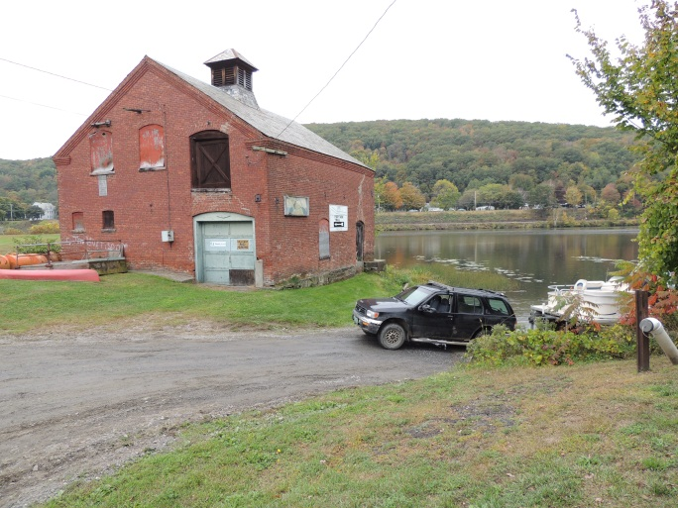 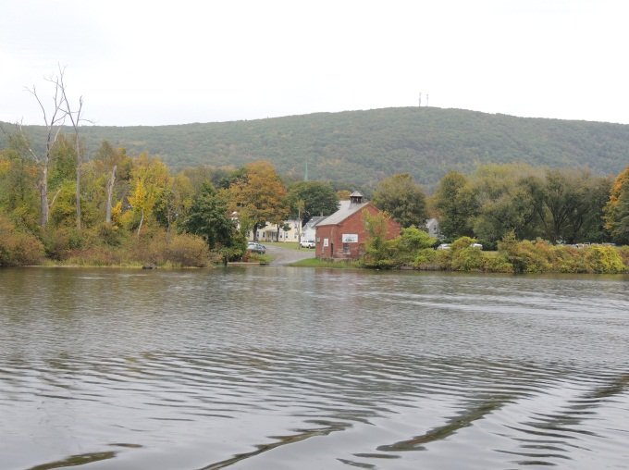

*Wilder*

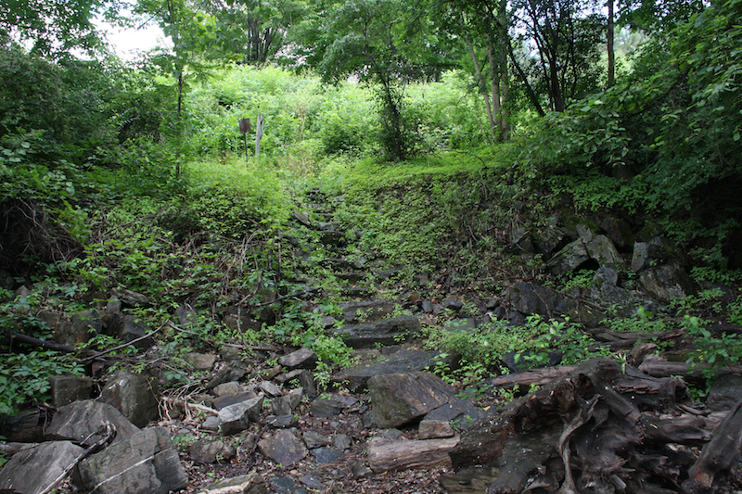The construction of the Wilder dam submerged 2.5 miles of significant rapids known as Olcott Falls which will not be replaced. The portage trail (shown in photo below) at Wilder Dam is long, steep, and dangerous for canoeists. Once at the bottom of the steep stone stairway, they must traverse and area similar to a sandbox mixed with football-sized stones. A shorter and safer path could be located on the opposite side of the river.

Sumner Falls, also known as Hartland Rapid, can be found seven miles below Wilder Dam. It is a series of ledges sprawled across a wide section of the Connecticut River that creates a whitewater play spot of approximately one-quarter mile. There are many surfing waves and the area is an excellent place for training beginning boaters and for play boaters. A large eddy on river right allows boaters to easily paddle back upriver and repeat the run. At generational and higher flow levels this site provides excellent surfing and currents for squirt boating. At moderate flows the run provides opportunities to complete a wide array of acrobatic tricks called freestyle paddling. However, there is a steep and challenging portage trail for paddlers not wishing to run the rapids. This trail cold certainly be improved and additional amenities could be added such as potable water, toilets, and campsites that would be used by play boaters at Sumner and by paddlers engaged in multiple-day trips on the river. However, the rapids at Sumner Falls are located seven miles downstream and could provide significant recreational opportunities. It is a popular kayak play spot used by paddlers from a wide region.

2. **Opportunities for Whitewater Paddling Enhancements at Bellows Falls**

The Bellows Falls project contains a .7-mile diversion that reduces in-stream flows other than for leakage. Any potential natural boatable flows during spillage are inaccessible, high, flashy, unpredictable, and are only available during periods of seasonal high spillage due to flooding. Even during natural spillage events, access to the reach is unavailable. Near the bottom of the reach, a low-head weir was installed which makes paddling additionally hazardous. Should whitewater boating in the bypassed reach be found feasible and required by the FERC, the licensee should be required to remove the low-head weir that now serves no function under the railroad bridge at the bottom of this reach.

Whitewater paddling opportunities eliminated by the project could be restored by the development of a whitewater park. The Bellows Falls bypass reach is a prime opportunity to create such an opportunity that could be of enormous economic value to the Bellows Falls, Vt., and Walpole, N.H., communities, as well as the wider region. During the Scoping meetings for Bellow Falls, representatives of the City enthusiastically supported the idea of looking into the activity. A professional designer of such parks—one with river engineers who have experience in constructing whitewater parks—should be hired to assess the opportunities.

In addition to recreation and aesthetics enhancements, the opportunity for controlled releases for whitewater boating with moderate, stable, and predictable whitewater flows could be made available from the late spring through early fall.

**3. Preservation of Cultural, Historical and Educational Resources**

*Vernon*

Dating to 1909, the Vernon Dam is the oldest of the Connecticut River dams currently seeking new licenses. It was the first hydroelectric dam to ship electricity overland to mills and customers not directly connected to the hydroelectric facility. The high line was the first of its kind. Educational opportunities should be coordinated with recreational improvements. A possible option identified during the Scoping meetings is to improve interpretative signage relative to the historical significance of the dam and high line transmission facilities. Records associated with the construction of the Vernon Dam (engineering studies, drawings, and photographs taken during construction) are of historical importance and should be preserved.

*Bellows Falls*

The first bridge across the Connecticut River was built on project lands, and Indian pictographs are visible on the rocks of the bypass reach. The dam was constructed in 1928 and is therefore old enough to be eligible for listing on the National Register of Historic Places. The canal associated with the dam is of itself highly significant, being the first such canal built in the U.S.

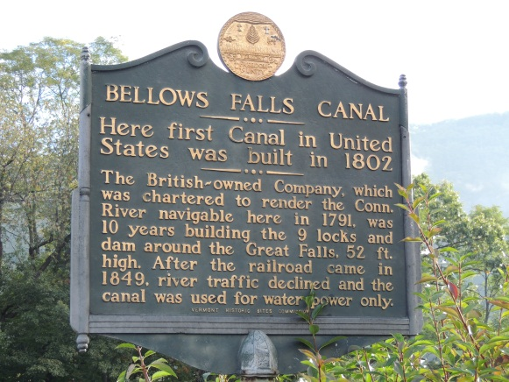

The current relicensing offers an opportunity to collect, catalogue and preserve important historical records held by the licensee related to the design and construction of the hydropower facilities. A study should determine what historical records remain, make suggestions for their safe storage, and suggest improvements at the projects to highlight the historical significance of each facility.

**Study Requests Pursuant to 18 CFR 5.9(b).**

These studies should include an analysis of why members of the public do not use certain resources associated with the Connecticut River in the project vicinity. As heard repeatedly during the scoping meetings, there is a lack of adequate recreational facilities on the Connecticut River in the project areas. This likely results in the cumulative displacement of use to other facilities in the watershed, possibly causing overcrowding at those resources. Although FERC’s Form 80 is done every 6 years by the licensee, there is no requirement to do any evaluation other than user identification through on site surveys; therefore, considerable use is missed depending upon numerous factors such as survey dates, weather and conditions. There is also no requirement to survey or reach out to known user groups.

The standard recreational use studies identify current users captured during the study period on specific days; they do not attempt to identify users and more important, user groups/organizations that regularly (or for events) utilize project resources and adjacent lands. In order to develop a complete picture of user needs and goals, the applicant needs to identify local, state and regional user groups (through their mailing/membership lists/web sites info) and reach out to those people through mails and/or online surveys to identify user preferences and concerns. An on-site survey also does not address why certain users do not utilize and area, which may be due to overcrowding or lack of desired facilities. Among the user groups that could be so utilized are the Connecticut River Watershed Council, the Appalachian Mountain Club (AMC), American Rivers, American Whitewater, WMCC and New England FLOW, to name just a few, along with the commercial outfitters and facilities on the river. Any organization that attended the scoping meetings or which provides comments or study requests should be so utilized for this purpose.

Conducting the necessary studies and implementing the measures needed to ensure the public has access to quality outdoor recreational resources are in the public interest. It is widely accepted that outdoor recreation offers significant benefits to the public. Outdoor recreation also has proven economic benefits for communities located near recreational resources.

**1. Study of Project Facilities to Support Multiple-day Self-Powered Boating Trips on the Connecticut River**

The NPS requests a study of the quantity, quality, and adequacy of land-based facilities operated by the licensees and associated with self-powered boating on the Connecticut River. This study should examine put-in and take-out facilities especially for canoes, kayaks, rowing shells and other self-powered watercraft; portage routes; campsites; parking and road access; seasons of operation of the facilities to match with actual river use; maintenance; water supplies and other amenities at campsites; and trash and sanitary facilities. The study should include a projection of usage during the proposed 30-year life of the licenses, and the opportunities for the project owners to buy land and/or interests therein from willing sellers in order to increase recreational benefits.

The study should examine the facilities that are necessary specifically for canoe, kayak and rowing shell access to the river. Information from the Vermont and New Hampshire SCORP study and from other river recreational interests suggests that interest in quiet water paddling is rising along with the sales of sea kayaks, rowing shells and canoes. Most of the existing facilities were designed for day use by motorboats with hard-surfaced ramps which may not be particularly suited to canoeists, especially those using wood-and-canvas or fiberglass canoes.

Paddlers attempting source to sea trips report challenging portages and limited opportunities for camping. According to the Connecticut River Paddler’s Trail organization, the ideal frequency of canoe campsites on flatwater stretches is one every five river miles, along with canoe and kayak access in each town. Campsite amenities provided by the licensee should be well signed for visibility form the river and standardized to include adequate canoe landing sites, toilets, potable water, trash disposal, picnic tables, and tent platforms or three-sided shelters.

The study should include both water and land-based trails. The Connecticut River Paddler’s Trail and the Connecticut River Birding Trail cross project boundaries and their collective interests should be included to ensure a watershed viewpoint, especially as it involves trail networks and associated facilities. Project lands at all the facilities, as well as adjacent lands should be studied for recreational and conservation improvement opportunities. In some cases, certain project lands could be added to existing public facilities (provided adequate resources are available to ensure appropriate long-term management) or placed under permanent conservation restrictions in order to improve conservation and recreation. The study should evaluate the adequacy and maintenance of existing trail systems for the term of the new license to be issued, and determine opportunities for additional hiking trails on project lands, and for linking those trails to existing trails. Such trails in the watershed could cross project boundaries, and adding to them could involve requiring the licensee to purchase additional land or interests therein.

Significant additional information relative to the use of the Connecticut River in the project areas exists, yet has not been included or evaluated in the PAD. There is inconsistent knowledge regarding multiple-day trips on the Connecticut River. Although the PAD lists facilities which are not owned or operated by the licensee, such as commercial operations, there is a lack of consistency about those facilities in terms of their seasons of use and what amenities they provide for public recreational use.

Several publications are widely used by paddlers and recreationalists. The primary source of information is *The Connecticut River Boating Guide: Source to Sea* (3rd ed.) published by the Connecticut River Watershed Council (2007). Recreational maps and guides to the river have been published for some reaches by KM Digital Productions in South Hadley, Mass., and are available from the Connecticut River Watershed Council. These foldout river maps cover the reaches from Vernon, Vt., to Turners Falls, Mass. (2008). Three other similar maps cover segments from Turners Falls (2007) down to Hartford, Conn. (2010), which is about the extent of the tidal zone. Most of those maps are in need of updates. In 1991, New England Cartographics in Amherst, Mass., published the *Connecticut River Guide in Massachusetts* by Doug Greenfield and Christopher J. Ryan. The Connecticut River Birding Trail organization located in White River Junction, Vt., has published maps detailing the upper valley section, the northern section, and the southern section of the river.

The Connecticut River Paddler’s Trail prepared *The* *Connecticut River Paddler’s Trail MA-CT Expansion Feasibility Study* in 2013*.*In that document, Noah Pollock of the Vermont River Conservancy examined the Massachusetts and Connecticut reaches of the river. The *Connecticut River Paddler’s Trail MA-CT Expansion Feasibility Study* contained a map of the river in Massachusetts created by the Trust for Public Lands with dots indicating recommended locations for additional campsites.

The study identified above will provide the defining mechanism for identifying sites that can be improved as well as additional sites that should be developed in order to ensure increased public opportunities and desire by currently discouraged users to participate in multi-day and local paddling trips on the river. The study will serve to identify potential properties whose acquisitions or fee or interests therein may provide appropriate opportunities for additional recreational facilities. The study should also serve to identify indirect effects of the hydro facilities that may be discouraging public use or displacing water-based recreation to other parts of the watershed. Cumulative effects would also be evaluated given the number of dams on the river and the fragmenting effect they have on recreational use and experiences.

Studies to evaluate the adequacy of public resources and recreational uses and needs are standard throughout the hydro relicensing process. Methodologies can be selected from among the recognized and accepted standards of the resource and public planning fields. Surveys of people who do NOT use the river or are displaced can employ randomized samples from several databases associated with various local, regional and national user groups. Sufficient information is available from the guidebooks and maps of the river that identify access points and campsites, as well as information contained in the PAD. Once a consultant is selected and approved, the information should be gathered and analyzed in a timely manner. The study would require spring, summer and fall seasons in order to locate river users and develop a statistically adequate sample. A consultant with experience in similar projects should be selected, in part to create relevant comparisons to other hydropower projects around the country.

Because there is no comprehensive text or guide that provides current information regarding carrying capacity of river-based recreational facilities associated with both individuals and groups of paddlers, the above described study will serve to bridge this information gap as well as to identify needed reconstruction or expansion of existing facilities or the development of new facilities. Any field research would need to be correlated with future use projections and standard requirements for water based access, campsites, sanitary and picnicking facilities and portages. Although the New Hampshire SCORP is up to date and provides valuable information relative to that state’s recreational facilities, recreational uses, needs and opportunities, the Vermont SCORP is relatively out of date and the study outlined above will serve to fill important information gaps.

**2a. Controlled Whitewater Flow Study in the Bypass Reach Below the Bellows Falls Dam With Potential for Development of a Whitewater Park**

The Bellows Falls project contains a .7-mile diversion that reduces in-stream flows except for minimum flow and during flood events. Natural boatable flows are frequently inaccessible, high, flashy, unpredictable, and are usually available only during periods of seasonal high spillage due to flooding.

Whitewater opportunities eliminated by the project could be partially restored if the licensee provided moderate, stable, and scheduled whitewater flows in the bypass reach that could be used from the late spring through early fall. The current operation of the project largely eliminates valuable seasonal paddling opportunities.

**2b. Controlled Whitewater Flow Study at Sumner Falls**

Wilder Station would release prescribed flows for this test. When the flows reach Sumner Rapids, a selected group of paddlers would run the rapid and then answer written questions about their experiences at that flow level. Wilder Station would release three or four or possibly several different flows, measured in cubic feet per second, and the paddlers’ experiences would be analyzed to determine the flows that work best at the rapid.

Controlled flow studies are routinely ordered to be conducted on FERC projects. These whitewater reaches offer a prime opportunity to restore a whitewater recreation that could be of enormous recreational and economic value to the community (in the case at Bellows Falls) and would be of high value to boaters in the region relative to Sumner Falls, an area which already sees a high volume of recreational use.

The goal of a whitewater flow study is to assess the presence, quality, access needs, flow information needs, and preferred flow ranges for river-based boating resources in a stepwise manner. The information to be obtained can be generally characterized as quantitative and qualitative descriptions of the following:

1. The range of optimal and acceptable flows for whitewater paddling in a whitewater park or natural falls setting.
2. The frequency, timing, duration and predictability of optimal and acceptable paddling flows under current conditions.
3. The access needs of whitewater boating use and the current and potential river access options for paddling.
4. The flow information needs of whitewater boating and the current and potential flow information distribution system.
5. The location, challenge, and other recreational attributes associated with specific rapids and other river features.

The information gathered is a combination of user-generated flow preferences and other engineering information on current and proposed operations (e.g. discharges), geographic information and basic recreational information. Essentially, the Bellows Falls Dam and Wilder Dam would release prescribed flows into the bypass reach for this test, perhaps over two days. For each release, a selected group of paddlers would run the rapid and then answer written questions about their experiences at each flow level. The dams would release several different flows, measured in cubic feet per second, and the paddlers’ experiences would be analyzed to determine the flows that work best at the rapid.

The Bellows Falls bypass reach would likely offer the public a high-quality whitewater boating resource when flow conditions are suitable. Conducting the necessary studies and implementing measures to ensure public access to outdoor recreation are in the public interest. In addition, the dry riverbed is not generally considered to be aesthetically pleasing and is in full view of many people who pass by on nearby Route 12. The rapids at Sumner Falls could provide an already popular recreation spot with the additional benefits of play boating while improving access for through paddlers.

Restoration of whitewater recreational opportunities in the Connecticut River has the potential to offer the region economic benefits. Numerous whitewater flow studies have been conducted during FERC relicensings on New England’s rivers (including the nearby Deerfield River) that have a long history of whitewater paddling use. According to the FERC, in order to fully evaluate the project’s effect on whitewater recreation opportunities and to balance potential enhancement opportunities with their cost, a controlled-flow whitewater boating study is relevant to the Commission’s public interest determination. This is especially true regarding the Bellows Falls bypassed reach. The potential high quality of this.7-mile long whitewater run should; therefore, be evaluated as should the opportunities for whitewater paddling at Sumner Falls.

Current and historic project operations leave significant information gaps and eliminate most of the low and moderate flows from the Bellows Falls reach, resulting in flows too low to paddle, too flashy, or consisting of spiking high flows that may be too dangerous to attempt. Intermediate paddlers, commercial paddlers, and general river-runners know relatively little about this river reach at low or moderate flows. The use of a controlled-flow analysis has been described in Doug Whittaker, Bo Shelby, and John Gangemi, Flows and Recreation: A guide to studies for river professionals (2005), p. 26-29, is available from the National Park Service website at: [www.nps.gov/hydro/flowrec.pdf](http://www.nps.gov/hydro/flowrec.pdf) . The goals include evaluating this stretch of river for use as a whitewater park, and evaluating the flows at which the run could best be utilized. In this case, river engineers with experience constructing whitewater parks, such as the McLaughlin Whitewater Design Group of Denver, Colo., should participate in designing the controlled-flow study.

Project operations eliminate most of the paddling days each year, including the virtual elimination of valuable and regionally needed summer paddling opportunities. This bypassed reach could be a high-quality paddling resource, and since paddling is a flow dependent activity, the project directly affects paddling on the Connecticut River, thereby providing a direct nexus. The results of a controlled flow study would help determine the need for license requirements for scheduled whitewater releases.

The study requests in the Bellows Falls bypass and at Sumner Falls should follow the standard methodology as described in Whittaker, referenced above. This methodology is designed to gather information to assess the presence, quality, and preferred flow ranges for river-based boating resources in a step-wise manner. The process steps are generally 1) desktop analyses, 2) on-land feasibility assessment, 3) on-water single flow assessment, 4) on-water multiple flow assessment. We expect and request the full implementation of this methodology.

Because the quality and flow needs of the resource are unknown, the NPS requests that an on-water multiple flow assessment be conducted. This study will need to take place on various dates and at variable flow levels throughout a spring and summer. Boating groups (such as American Whitewater, NEFLOW and the AMC) can work with the licensee to document the known information regarding the river and would help provide volunteer paddlers and technical support for the studies as appropriate. The whitewater boating study methodology identified above has been used on dozens of other FERC regulated reaches. This study should include an examination of the access issues for the bypass reach and the take-out below. The whitewater boating community would work with the applicant to keep costs reasonable and the quality of information high. Prior to conducting paddling runs in the bypass reach, the licensee should remove the small low-head weir at the base of the run and restore the natural shape of the river in consultation with whitewater engineers. A collaborative approach sought by the paddling community including in-kind contributions of time and expertise should help consultants complete these studies on behalf of the licensee for a reasonable cost.

The studies will require integration of known information followed by an organized flow study during which several flows are paddled by boaters, with still image and video documentation, surveys of the boaters, a guided conversation among the boaters, and a written report. Given that this is a bypass reach with some minimal access and relatively straightforward hydrology, and given the collaborative approach sought by the paddling community, including in-kind contributions of time and expertise, a consultant should be able to complete this study on behalf of the licensee for a very reasonable cost.

The potential for developing a new, high quality whitewater park as a recreational facility is a new idea, but is exactly the type of idea that often emerges from the Scoping process. Representatives of Bellows Falls and nearby Lebanon, New Hampshire were quite enthusiastic about looking into this idea and it is similar to numerous such proposals to have come out of other FERC Scoping process, many of which have come to fruition. However, current and historic project operations provide no information and have virtually eliminated all stable, low and moderate flows within the bypassed reach. Spiking flows on the order of 50,000 cfs are not uncommon, but intermediate paddlers, commercial paddlers, and general river-runners know little about this bypass reach under any flow conditions. This study will determined if there is adequate potential to build a whitewater park that offers a quality whitewater resource with safe and adequate put-in, take-out, and return facilities that allow for use of the entire bypass reach. The Bellows Falls dam diverts the entire flow except during flood events and normal seepage resulting in the elimination of a possible valuable and regionally rare urban summer paddling opportunity. Therefore, the project nexus is direct and the study results may support license requirements to develop a whitewater park and provide scheduled releases in the bypass reach.

The NPS recognizes that scheduled or regular flows into the bypassed reach impact power generation, fish passage, and other environmental variables and should be examined in the broader context. Therefore, the establishment and construction of a whitewater park with possible fish passage should thoroughly evaluate design standards such as those developed by the McLaughlin Whitewater Design Group or similar firm which has worked extensively with municipalities, public utilities, the U.S. Army Corps of Engineers, and paddling groups throughout the United States. The analysis should recommend whitewater structures to improve the run, and the work required to construct public access put-in, take-out return shuttle facilities for boaters, and possible additional fish passage.

The PAD proposes no whitewater feasibility analysis. This no-action step will reveal nothing about the project impacts on whitewater recreation or opportunities for protection, mitigation, or enhancement measures. There is currently no information relative to the relationship between specific low and moderate flows and the paddling experiences they might provide. A desktop analysis cannot generate this information. Without this information, the FERC cannot fully evaluate or define the project impacts, nor propose and consider provision of releases that provide targeted recreational experiences and related economic benefits to the host community and the region.

3. **Preservation of Cultural, Historical, and Educational Resources**

A study should be undertaken to determine a variety of options for educating the public about these historic dams, and to determine what actions should (or should not) be taken to preserve artifacts and provide education. This study should also address the need to document, catalogue, preserve and where appropriate, display the work of the engineers who built the Dams. Vernon, constructed in 1909 was the first dam to ship electricity to remote locations and shipped electricity to the mills of Massachusetts, thus playing a role in the labor history of the United States. The site of the Bellows Falls Dam is where the first bridge across the Connecticut River was constructed along with the earliest canal in the U.S. Similar historic resources are likely associated with construction of the Wilder Dam.

Historic resources including drawings, photographs, blueprints, inventories and plans should be considered historical resources worthy of preservation for the public benefit. The engineering records related to the construction of the dams are a valuable element of our social and industrial history. The licensee currently possesses roughly two dozen scrapbook volumes of these records and photos. Each volume is numbered, but the numbers suggest there may be a total of 300 or more scrapbooks in existence. The study should discover what records remain and recommend plans for permanently preserving them and making them available to historians and researchers.

This relicensing proceeding can provide assistance to visitors, schools, and river travelers to better understand the remarkable history of the Projects and the area. It offers perhaps the last chance to rescue important historical records held by the licensees related to the design and construction of the hydropower facilities. The study should determine what historical records remain, make suggestions for their safe storage, and suggest improvements at the projects to highlight the historical significance of the facilities.

The information to be gathered pertains to the original construction of the three dams and might also offer valuable insight into the pre-dam condition of the river and its environs. The nexus is direct as the licensee currently possesses scrapbooks, photographs, construction plans, and other historical records related to the construction of the dams. Preservation of such documentation should be a license requirement.

For assistance, the licensee would work with the New Hampshire Division of Historical Resources and the Vermont State Historic Preservation Office whose staffs could recommend how to best handle and preserve the scrapbook records and other historical information about building the dam. The work involved to locate the records owned by TransCanada would be internal, with advice and recommendations provided by professional historians once the scope and location of the documents is determined.

4. **Creation of a Decommissioning Fund**

The NPS believes a study of the financial production of each individual facility that is being relicensed is appropriate. The analysis and/or NEPA document to be prepared should evaluate creating an escrowed decommissioning or trust fund for the dam and pumped storage project. Given that both parent companies of the licensees are foreign owned, deregulation, future ownership changes and the potential financial impacts of climate change can affect the financial health of the current and potential future owners. The licensees, not the public, should not be burdened with potential costs associated with decommissioning. FERC license conditions often address additional mitigation such as trust funds, dam decommissioning funds, and public committees to oversee license implementation. To that end, the NPS requests a study of both the fiscal health of each TransCanada facility on the river and recommendations for the creation of a decommissioning fund or trust fund to protect the public interest.

New England’s rivers are littered with abandoned dams. Over the centuries, companies have failed, and weather events or human error have crippled dams that were then simply left behind. Although the owners of these facilities are presently in good financial health and can meet the requirements over the life of a new license, times and circumstances can change. Unforeseen events might cause either business or physical failure. A number of extraordinary storm events (such as Hurricane Irene and several extreme drought, rain and snow events) have occurred in New England in recent years, thereby increasing the need to fully evaluate a potential dam failure and the associated costs. International business remains risky and both TransCanada and FirstLight are foreign owned. Changing foreign regulations, currency devaluations or circumstances completely out of FERC’s purview could compromise the health of the licensee.

The economic security of a federally licensed hydropower dam on the longest river in New England is clearly in the public interest. Many hydropower projects support robust recreation economies and produce a public good by generating renewable forms of electricity. The historical record demonstrates—by the thousands of abandoned dams on New England’s rivers—that the public should not accept the burden of industrial failure, especially associated with dams. It has become common to create decommissioning funds at such federally licensed facilities as a way of insuring the public interest against having to pay for removal of a damaged facility or to take over from a failed corporation. Therefore, the American public should be insured against the burden of decommissioning costs. A study could examine the health of the facilities and their owner and recommend the terms of a license requirement for decommissioning.

There is a direct nexus between Project operations and the economic viability of each individual dam. Study results could lead to a license requirement setting up an escrowed decommissioning or trust fund to protect the public interest. The financial viability portion of the study would follow normal procedures in accounting and financial management. The study itself would be relatively inexpensive; however, adequately funding the trust would more challenging. The NPS is unaware of alternative means of securing the public from risks that the corporations or the physical assets might fail during the course of the federal license.

**Conclusion**

The National Park Service appreciates the opportunity to comment on the PAD and to present study requests we believe to be in the public interest. NPS Hydro Program staff will remain available throughout the course of these proceedings to assist the applicant, other resource agencies and non-governmental organization in the development, conduct and evaluations of the studies requested. Questions or comments on this submittal should be addressed to Kevin Mendik at [kevin_mendik@nps.gov](mailto:kevin_mendik@nps.gov) or by phone at 617-223-5299.

Respectfully submitted,



Kevin R. Mendik

NPS Hydro Program Manager

Northeast Region